**BOOKING MANAGEMENT SYSTEM**

END TERM REPORT

*by*

**Anand Gupta** - K19JFB40 - 11904979

**Prakhar Srivastava** - K19JFB 41 - 11904878

**Sandesh Acharya** - K19JFB 42 - 11904881



**Department of intelligent systems**

**School of Computer Science Engineering**

**Lovely Professional University, Jalandhar**

**Student Declaration**

This is to declare that this report has been written by us. No part of the report is copied from other sources. All information included from other sources have been duly acknowledged. We aver that if any part of the report is found to be copied, We shall take full responsibility for it.

Anand Gupta

K19JFB40

Prakhar Srivastava

K19JFB41

Sandesh Acharya

K19JFB42

**TABLE OF CONTENTS**

**TITLE PAGE NO.**

* 1. Background and Objective of Project Assigned…………………………….. 05
     1. Introduction of the Project……………………………………………. 05
     2. Objective of the Project………………………………………………. 06
     3. Abstract of the Project……………………………………………….. 07
     4. Scope of the Project………………………………………………….. 08
  2. Description of the Project……………………………………………………. 10
     1. The proposed system has the following requirements………………… 10
     2. Features of the Project…………………………………………………. 11
     3. Feasibility Study……………………………………………………… 13
        + 1. Economical Feasibility………………………………. 13
          2. Technical Feasibility…………………………………. 13
          3. Operational Feasibility……………………………….. 13
     4. Implementation Methodology…………………………………………. 14
     5. Modules of Online Movie Ticket Booking Management System…….. 15
     6. Conclusion……………………………………………………………… 15
     7. Web Page Picture ………………………………………………………. 16
     8. References and Bibliography………………………………………….. 17

**BONAFIDE CERTIFICATE**

Certified that this project report “BOOKING MANAGEMENT SYSTEM” is the bonafide work of “Anand Gupta , Prakhar Srivastava , Sandesh Acharya” who carried out the project work under my supervision.

Kunj Marken

Asst. Professor

25669

Department of Intelligent System

**Background and Objective of Project Assigned**

Introduction of the Project

The "Online Movie Ticket Booking Management System" has been developed to override the problems prevailing in the practicing manual system. This software is supported to eliminate and in some cases reduce the hardships faced by this existing system. Moreover this system is designed for the particular need of the company to carry out operations in a smooth and effective manner.

The application is reduced as much as possible to avoid errors while entering the data. It also provides error message while entering invalid data. No formal knowledge is needed for the user to use this system. Thus by this all it proves it is user-friendly. Online Movie Ticket Booking System , as described above, can lead to error free, secure, reliable and fast management system.

Every Online Movie Ticket Booking System has different Movie needs, therefore we design exclusive employee management systems that are adapted to your managerial requirements. This is designed to assist in strategic planning, and will help you ensure that your organization is equipped with the right level of information and details for your future goals. Also, for those busy executive who are always on the go, our systems come with remote access features, which will allow you to manage your workforce anytime, at all times. These systems will ultimately allow you to better manage resources.

To increase my knowledge horizon in technologies like HTML, CSS, JAVA SCRIPT.

Objective of the Project

The Project **"Booking Management System"** is the process where user can directly buy movie tickets online from a multiplex website interactively in real-time without an intermediary service over the Internet. The given system provides the detailed working of the **Booking Management System** processing and what all happens whenever we or any one of us goes to book movie tickets online.

The real of world wide web have spread across millions of people, so internet has become by far the best platform for online booking system today. Now days everything is online it is easier to user book and do work through online. The user can book the ticket through online by using digital devices it is very easier and it is good for marketing also. This is very popular in present as well as in future this online booking system has a large scope in everywhere.

The website is a online movie booking system through which users can buy the ticket and they have many option to choose the movie and user(s) can select the seat through online. The online movie booking system manage all the things in smooth way and user's can get the update in his account related to any new movie.

The system is very useful for the user as they can post the images of their and edit details and give their reviews to the system and theater. The system can store your full information in the database system which stores all user information.

Since this system uses database and control. It needs the retrieval of information from the database. It stores all data of the user's and it is provides easy linking to the database, along with the flexibility required to develop a user friendly front end.

Abstract of the Project

The purpose of Online Movie Ticket Booking System is to automate the existing

manual system by the help of computerized equipments and full-fledged computer

software, fulfilling their requirements, so that their valuable data/information can be

stored for a longer period with easy accessing and manipulation of the same. The

required software and hardware are easily available and easy to work with.

Online Movie Ticket Booking System, as described above, can lead to error free,

secure, reliable and fast management system. It can assist the user to concentrate on

their other activities rather to concentrate on the record keeping. Thus it will help

organization in better utilization of resources. The organization can maintain

computerized records without redundant entries. That means that one need not be

distracted by information that is not relevant, while being able to reach the information. The aim is to automate its existing manual system by the help of computerized equipments and full-fledged computer software, fulfilling their requirements, so that their valuable data/information can be stored for a longer period with easy accessing and manipulation of the same. Basically the project describes how to manage for good performance and better services for the clients.

Scope of the Project

It may help collecting perfect management in details. In a very short time, the

collections will be obvious, simple and sensible. It will help a person to know the

management of passed year perfectly and vividly. It also helps in current all works

relative to Online Movie Ticket Booking System. It will be also reduced the cost of

collecting the management & collection procedure will go on smoothly.

Our project aims at Business process automation, i.e. we have tried to

computerize various processes of Online Movie Ticket Booking System.

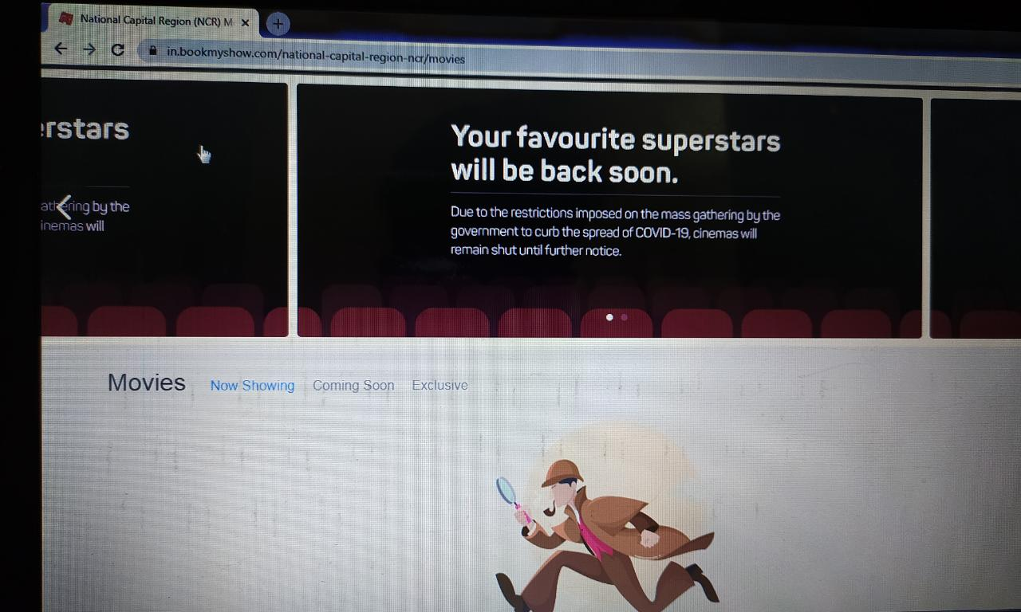

* In computer system the person has to fill the various forms & number of copies of the forms can be easily generated at a time.
* In computer system, it is not necessary to create the manifest but we can directly print it, which saves our time.
* To assist the staff in capturing the effort spent on their respective working areas.
* To utilize resources in an efficient manner by increasing their productivity through automation.
* The system generates types of information that can be used for various purposes.
* It satisfy the user requirement
* Be easy to understand by the user and operator
* Be easy to operate
* Have a good user interface
* Be expandable
* Delivered on schedule within the budget.

**Description of the Project**

The proposed system has the following requirements:

* System needs store information about new entry of Movie.
* System needs to help the internal staff to keep information of Tickets and find them as per various queries.
* System need to maintain quantity record.
* System need to keep the record of Booking.
* System need to update and delete the record.
* System also needs a search area.
* It also needs a security system to prevent data.

Features of the Project

* Product and Component based
* Creating & Changing Issues at ease

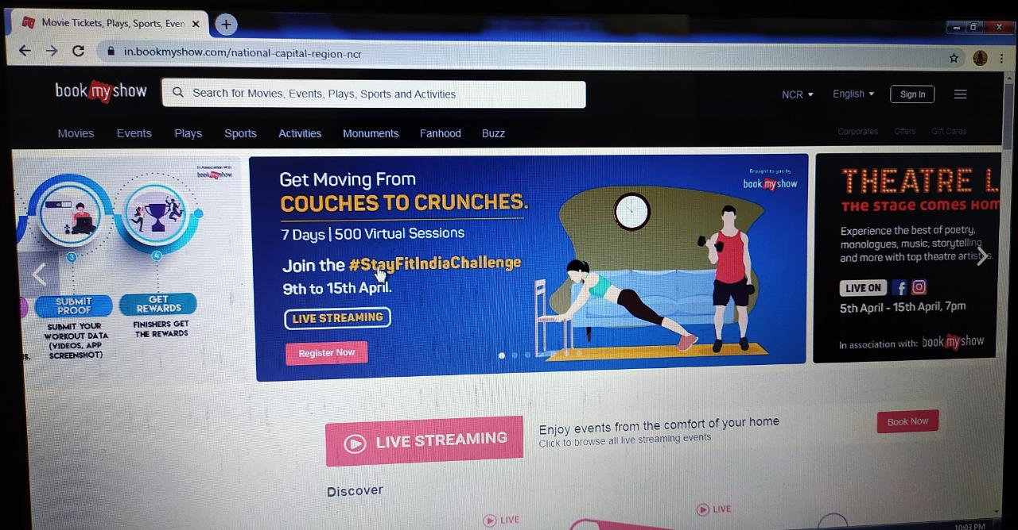

* Query Issue List to any depth
* Reporting & Charting in more comprehensive way
* User Accounts to control the access and maintain security
* Simple Status & Resolutions
* Multi-level Priorities & Severities.
* Targets & Milestones for guiding the programmers
* Attachments & Additional Comments for more information
* Robust database back-end
* Various level of reports available with a lot of filter criteria’s
* It contains better storage capacity.
* Accuracy in work.
* Easy & fast retrieval of information.
* Well designed reports.
* Decrease the load of the person involve in existing manual system.
* Access of any information individually.

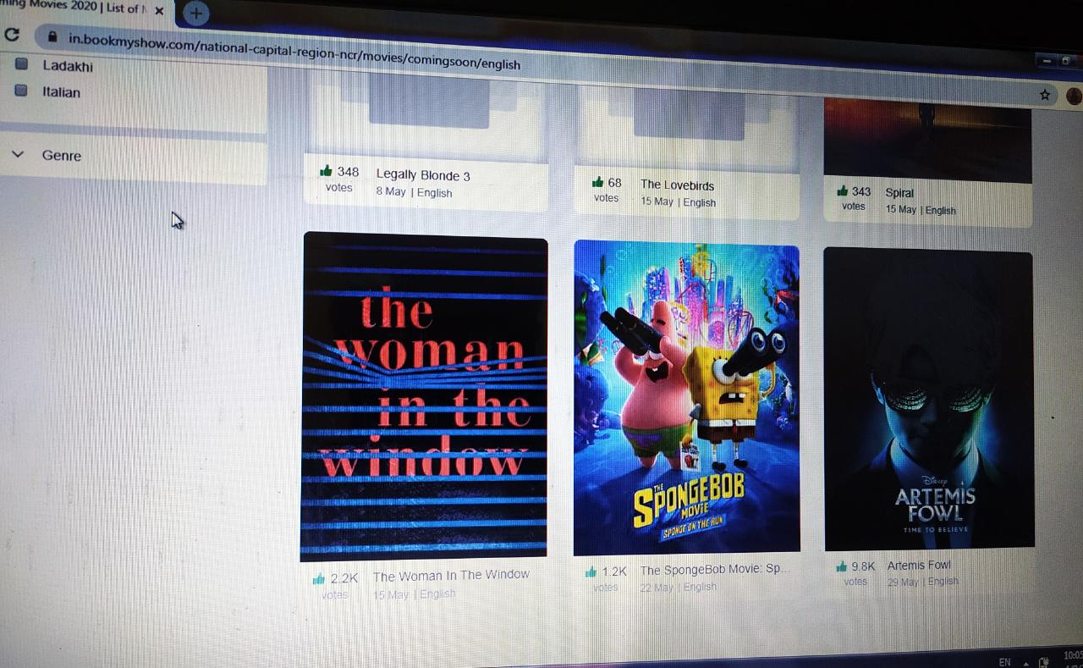

* Work becomes very speedy.
* Easy to update information

Feasibility Study:

After doing the project Online Movie Ticket Booking System, study and analyzing

all the existing or required functionalities of the system, the next task is to do the

feasibility study for the project. All projects are feasible - given unlimited resources and infinite time.

Feasibility study includes consideration of all the possible ways to provide a solution to the given problem. The proposed solution should satisfy all the user requirements and should be flexible enough so that future changes can be easily done based on the

future upcoming requirements.

A. Economical Feasibility

This is a very important aspect to be considered while developing a project. We

decided the technology based on minimum possible cost factor.

All hardware and software cost has to be borne by the organization.

Overall we have estimated that the benefits the organization is going to receive

from the proposed system will surely overcome the initial costs and the later on

running cost for system.

B. Technical Feasibility

This included the study of function, performance and constraints that may affect

the ability to achieve an acceptable system. For this feasibility study, we studied

complete functionality to be provided in the system, as described in the System

Requirement Specification (SRS), and checked if everything was possible using

different type of frontend and backend platforms .

C. Operational Feasibility

No doubt the proposed system is fully GUI based that is very user friendly and all

inputs to be taken all self-explanatory even to a layman. Besides, a proper training has been conducted to let know the essence of the system to the users so that they feel comfortable with new system. As far our study is concerned the clients are comfortable and happy as the system has cut down their loads and doing.

Implementation Methodology:

Model View Controller or MVC as it is popularly called, is a software design pattern for developing web applications. A Model View Controller pattern is made up of the

following three parts:

* **Model** - The lowest level of the pattern which is responsible for maintaining data.
* **View** - This is responsible for displaying all or a portion of the data to the user.
* **Controller** - Software Code that controls the interactions between the Model and View.

MVC is popular as it isolates the application logic from the user interface layer and

supports separation of concerns. Here the Controller receives all requests for the

application and then works with the Model to prepare any data needed by the View. The

View then uses the data prepared by the Controller to generate a final presentable

response. The MVC abstraction can be graphically represented as follows.

MVC (Model View Controller Flow) Diagram

DATA FLOW DIAGRAMS



Modules of Online Movie Ticket Booking Management System:

* Home Module: It is home page of this website, from here we can book movie tickets.
* About Module: It is for brief information of the website.
* Contact Module: It is for any queries or complain
* Timing Module: Used for managing the Show Timing information.
* Cinemas Module: Used for managing the information and details of the Tickets
* Movie Module: Used know the Movie details.

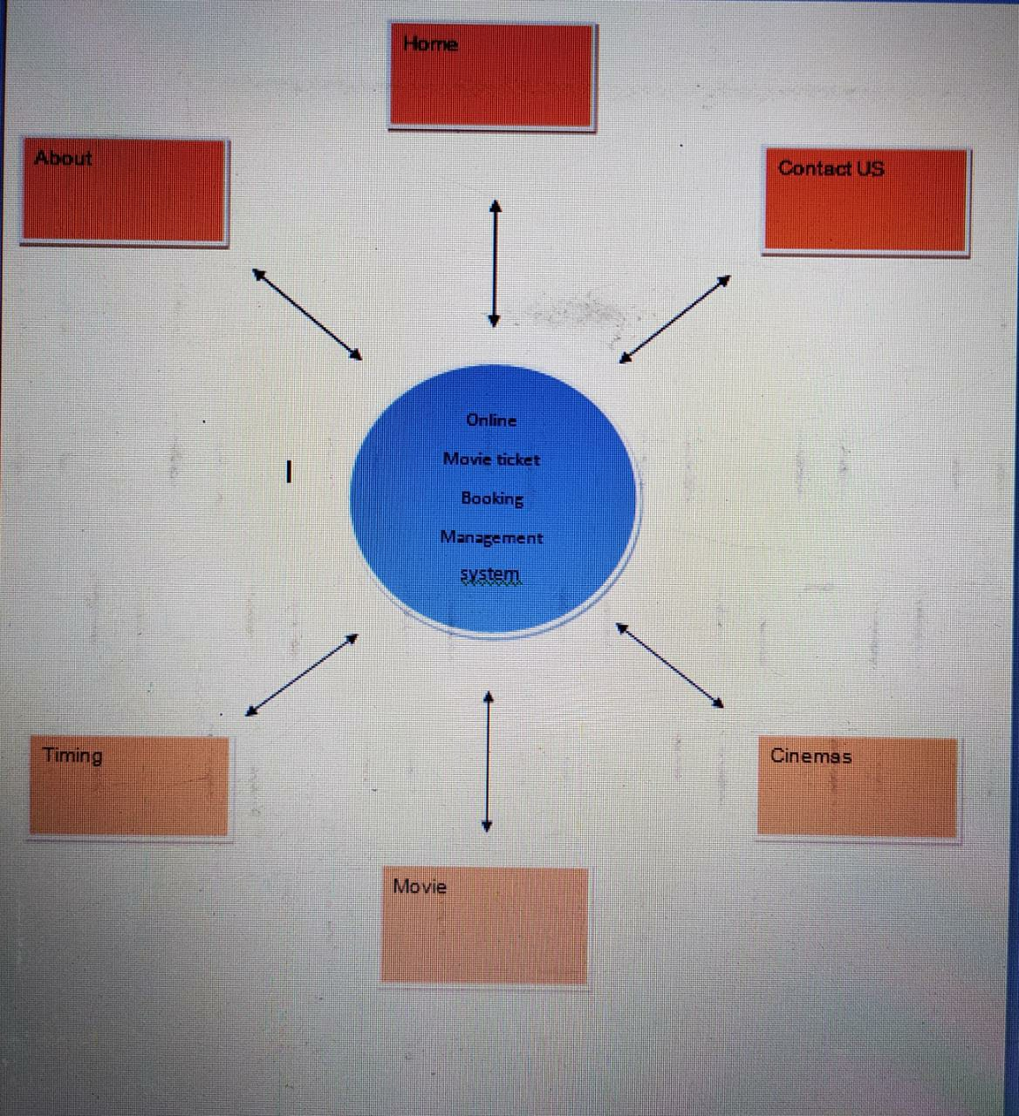

Conclusion:

* We have learnt how to design website using html and CSS.
* In this project we have also learnt how to make different tab in one website.
* In this project we designed contact us form where user can contact us.
* From this website user can book Movie ticket from their home.

Web Page Picture:

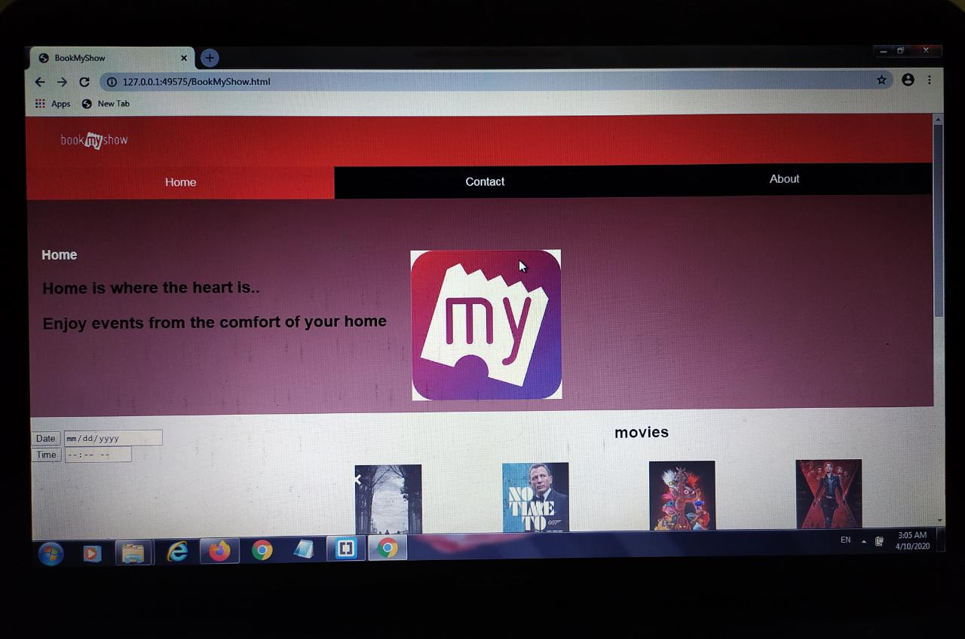

References and Bibliography:

* Google for problem solving
* http://www.javaworld.com/javaworld/jw-01-1998/jw-01-Credentialreview.html
* Database Programming with JDBC and Java by O'Reilly
* Head First Java 2nd Edition
* http://www.jdbc-tutorial.com/
* Java and Software Design Concepts by Apress
* https://www.tutorialspoint.com/java/
* http://www.javatpoint.com/java-tutorial
* https://docs.oracle.com/javase/tutorial/
* http://www.wampserver.com/en/
* http://www.JSP.net/
* http://www.tutorialspoint.com/mysql/
* http://d.apache.org/docs/2.0/misc/tutorials.html
* https://in.bookmyshow
* https://w3school
* <https://javasript>
* https://movieticket